**System Requirements**

**for**

**Data Center Capacity Planning Tool**

**Table of Contents**

**1.** **INTRODUCTION** 3

**2.** **PRODUCT AND SERVIEC DESCRIPTION** 3

2.1. PROUDCT CONTEXT 3

2.2. USERS 3

2.3. USE CASES 3

2.4. ASSUPTIONS 3

**3.** **SYSTEM REQUIREMENTS** 4

3.1. FUNCITONAL 4

3.2. INTERFACE 4

3.3. PERFORMANCE 4

3.4. SECURITY 5

3.5. ADMINISTRATION 5

**4.** **APPENDIX** 5

1. **INTRODUCTION**

Most of the modern IT infrastructure operation management tools treat capacity management as management of existing capacity; and often separate capacity management with demand management. A few tools do provide forecast capabilities but mostly too rely on system performance monitoring and the forecast is based on historical growth trend.

It is hard to find a tool that provides both tactical management and strategic planning for datacenter capacities, since now “Cloud” is the mainstream now, few people worry about capacity breach any more, thanks to the elasticity of could computing power.

Nevertheless, new datacenters are still being built every day and there will still be a lot of companies and organizations that own and manage their dedicated datacenter, no matter privately built or co-located. Therefore, there need to be a tool that can accurately reflect existing capacity consumption, capture short-term and long-term requests, and eventually translate those requests into quantifiable capacity demand.

This product is inspired by a prototype tool that once used in a previous project for a world leading bank. The purpose is to develop that prototype into a fully featured commercial product so that it can fill the gap in the existing IT operation tool chain.

1. **PRODUCT AND SERVIEC DESCRIPTION**
   1. PROUDCT CONTEXT

This product will be used during the analysis process of building a new datacenter and datacenter day-to-day operation.

* 1. USERS

Datacenter engineers, Infrastructure operation managers

* 1. USE CASES

Case I - During a datacenter migration project, a datacenter engineer leverages the tool to associate existing datacenter capacity utilization to future capacity demand to determine the minimum and maximum capacities required for the new datacenter.

Case II - An infrastructure operation manager leverages the capacity utilization dashboard, ranging from past 12 months to future 12 months, published from the tool to evaluate risk of potential capacity break, and make purchasing decisions.

* 1. ASSUPTIONS

1. Demand data are available and accurate;
2. Users will only install standard equipment with clear specifications;
3. **SYSTEM REQUIREMENTS**

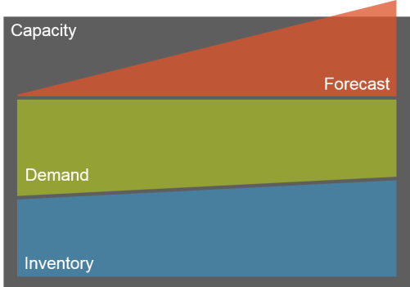

* 1. FUNCITONAL

1. The product will consist of 4 modules:
   * Inventory
   * Capacity
   * Demand
   * Forecast
2. *Inventory*
   1. Able to store all inventory items and with the capability of grouping items according to pre-defined rules;
   2. The tool must be able to pull nameplate ratings of each device model from manufacturers or Technopedia;
   3. The tool must be able to track and show the dependencies between each configuration items, such as parent-child relationships;
   4. The dependency relationships include: power, network and physical location.
3. *Capacity*
   1. The tool must be able to store existing datacenter capacities in all aspects to atomic level: power, cooling, floor space, floor bearing, rack space, network bandwidth, network port, storage volume etc.
   2. Be able to store and/or import capacity utilization statistics with timestamps;
   3. Be able to calculate average capacity consumption per each device based on historical data.
4. *Demand*
   1. The tool must be able to capture operational demand (devices that are planned to be installed or decommissioned)
   2. as well as strategic demand (project level compute demand estimate);
   3. Be able to translate those demands into corresponding datacenter capacity requirements – power, cooling, rack space, network, storage etc.
5. *Forecast*
   1. The tool must be able to conduct timeline analysis by virtually installing future demand into datacenter and calculate prospected capacity utilization.
   2. The timeline analysis data can be break down to atomic level, i.e. the overall data can be drilled down by different aspect, such as date, location, LOB etc.
   3. The tool can conduct “what-if” analysis, i.e. adding hypothetical demand, moving demand across locations, deferring installation date, change device models etc.
6. The 4 modules of the tool can be offered as one solution or be selected separately as 4 different tools;
   1. INTERFACE

User Interface

1. The application must be web based, and should work on most of the mainstream web browsers without any additional installation on client side;
2. All user inputs are validated against pre-defined rules to keep the database clean; No “free text box” input unless absolutely necessary;
3. OLAP analysis result should be able to be saved/exported as .xls, .jpg and .pdf files;
4. For Inventory, Demand and Capacity modules, users are able to input data via bulk upload; system should accept .csv, .xls and .xml.

System Interface

1. All database level operations are handled by API, which has build-in policies to ensure data quality;
2. Inventory, operational demand and strategic demand data should be able to be synchronized with other tools or databases;
   1. PERFORMANCE
3. Ajax or similar technologies must be used to achieve instant response in analysis module;
4. The database should be able to handle 1,000+ ~ 10,000,000+ data entries;
5. 1. SECURITY
6. Role-based access control;
7. Able to integrate authentication with active directory or other authentication service such as Single Sign On (SSO);
   1. ADMINISTRATION
8. The product can be offered either as a hosted service in the cloud, as a package for on-premises hosting or as a portable tool that can be run from a PC;
9. All transactions in OLTP database are logged, including logon, create, update, delete, grant, revoke etc.
10. **APPENDIX**

Use Case Diagram

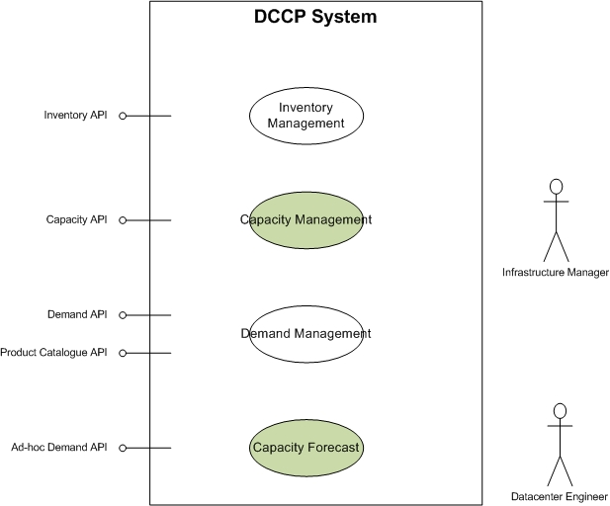

Data Flow Diagram – Level 0

